Assignment #3

Multi-Spectral Imaging & Image Enhancement

**Approach**

For this assignment, I started from scratch in Matlab. My approach was to work step by step through the paper in order to get the final image. The paper was very easy to read and laid out the steps pretty clearly so it was a good guide. My first step was finding a way to perform a discrete Haar decomposition on the images given. After that, the hardest part I worked on a way to create a weighted region mask. I tried to implement the formulas given in the paper at first, but I then used other methods that created similar results. After creating a mask, I decomposed the VIS and NIR images in to their respective coefficients. After adding the two coefficients together to work with the Matlab input requirements, I performed a Haar inverse wavelet transform on the images and the final image was the combined image with the watermark enhanced on the image of the paper.

**Difficulties**

This assignment was difficult for me at first trying to use Visual Studio and OpenCV. I could not get the paths to work, nor get OpenCV to be recognized by visual Studio. I figured since OpenCV was only being used to read in the images, that I could do this more efficiently in Matlab. From a coding standpoint, the difficulties came in making the Haar decomposition. It took a while to figure out how to get the matrices to work but once I got it I realized how simple the implementation is. Another area that I ran into issues was in getting the normalized histograms in order to make the weighted region image. I ended up normalizing the image using weighted gradients and then created a weighted region mask (which I later remembered we did not have to do). I spent a lot of time trying to figure out how to align the images in Photoshop and I was successful in aligning the $5 bills (images attached), but I had issue aligning the book file and the paper file because they were so dark. After unsuccessfully aligning them in Photoshop, I borrowed Ahn’s images so that I could test and run my code.

**Instructions to Run:**

Run the function assignment3Driver.m and as input put the filename of the VIS image first, then the NIR image. Make sure you enter them in quotes. Example: assingment3Driver(‘VISAligned.jpg’, ‘NIRAligned.jpg’).

**Closing Thoughts**

I am so happy with this assignment because I finally achieved the right finished product! While it wasn’t very difficult or code intensive I am happy to finally have a project to show. I also learned a lot in this project about Haar wavelets and how you can combine images from different spectral bands to create an overall enhanced image. While I didn’t have to create a weighted region mask or a bilateral filter, I am proud of my attempts to create both!

Images/Results

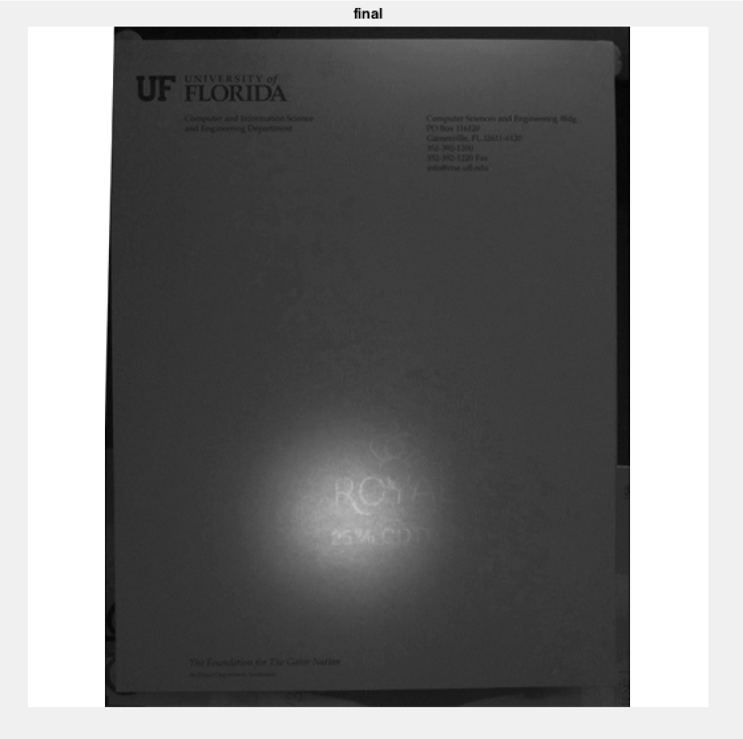

above image is the final result of the combination with equal weights to the NIR and VIS images

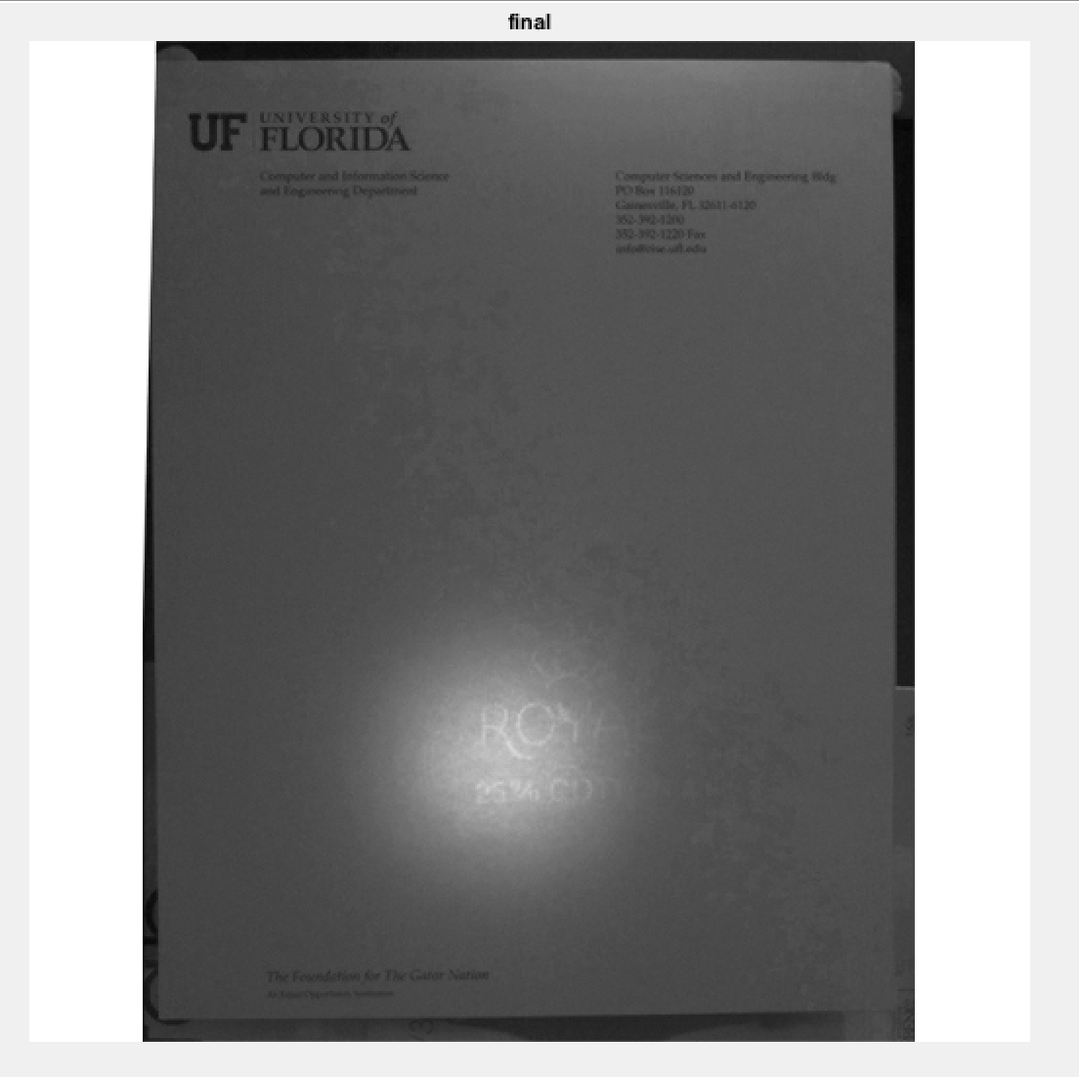

the above result is the final combination of the two images where the VIS values were weighted higher than the NIR

The following images are the Vertical, Horizontal, and Diagonal components of the NIR and VIS images

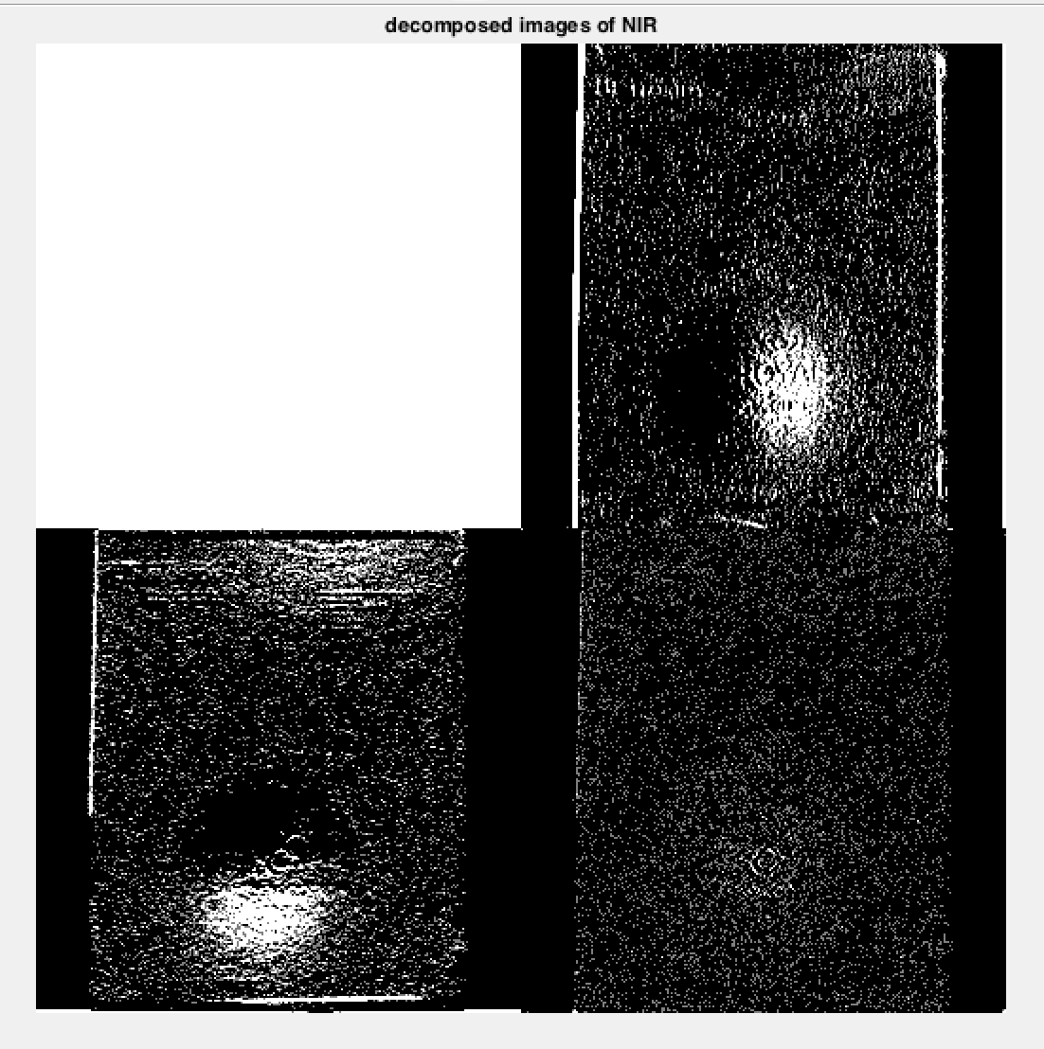

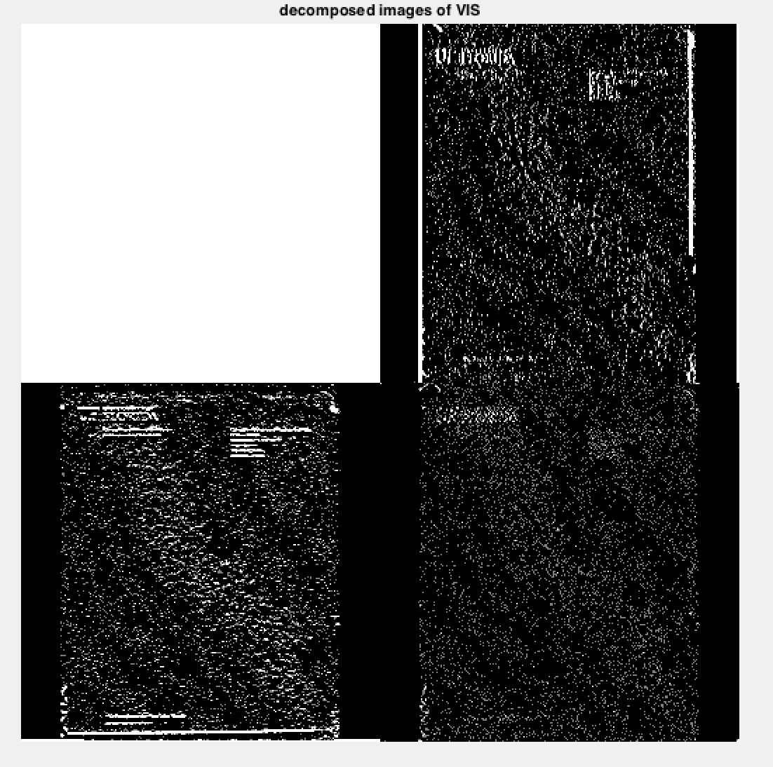

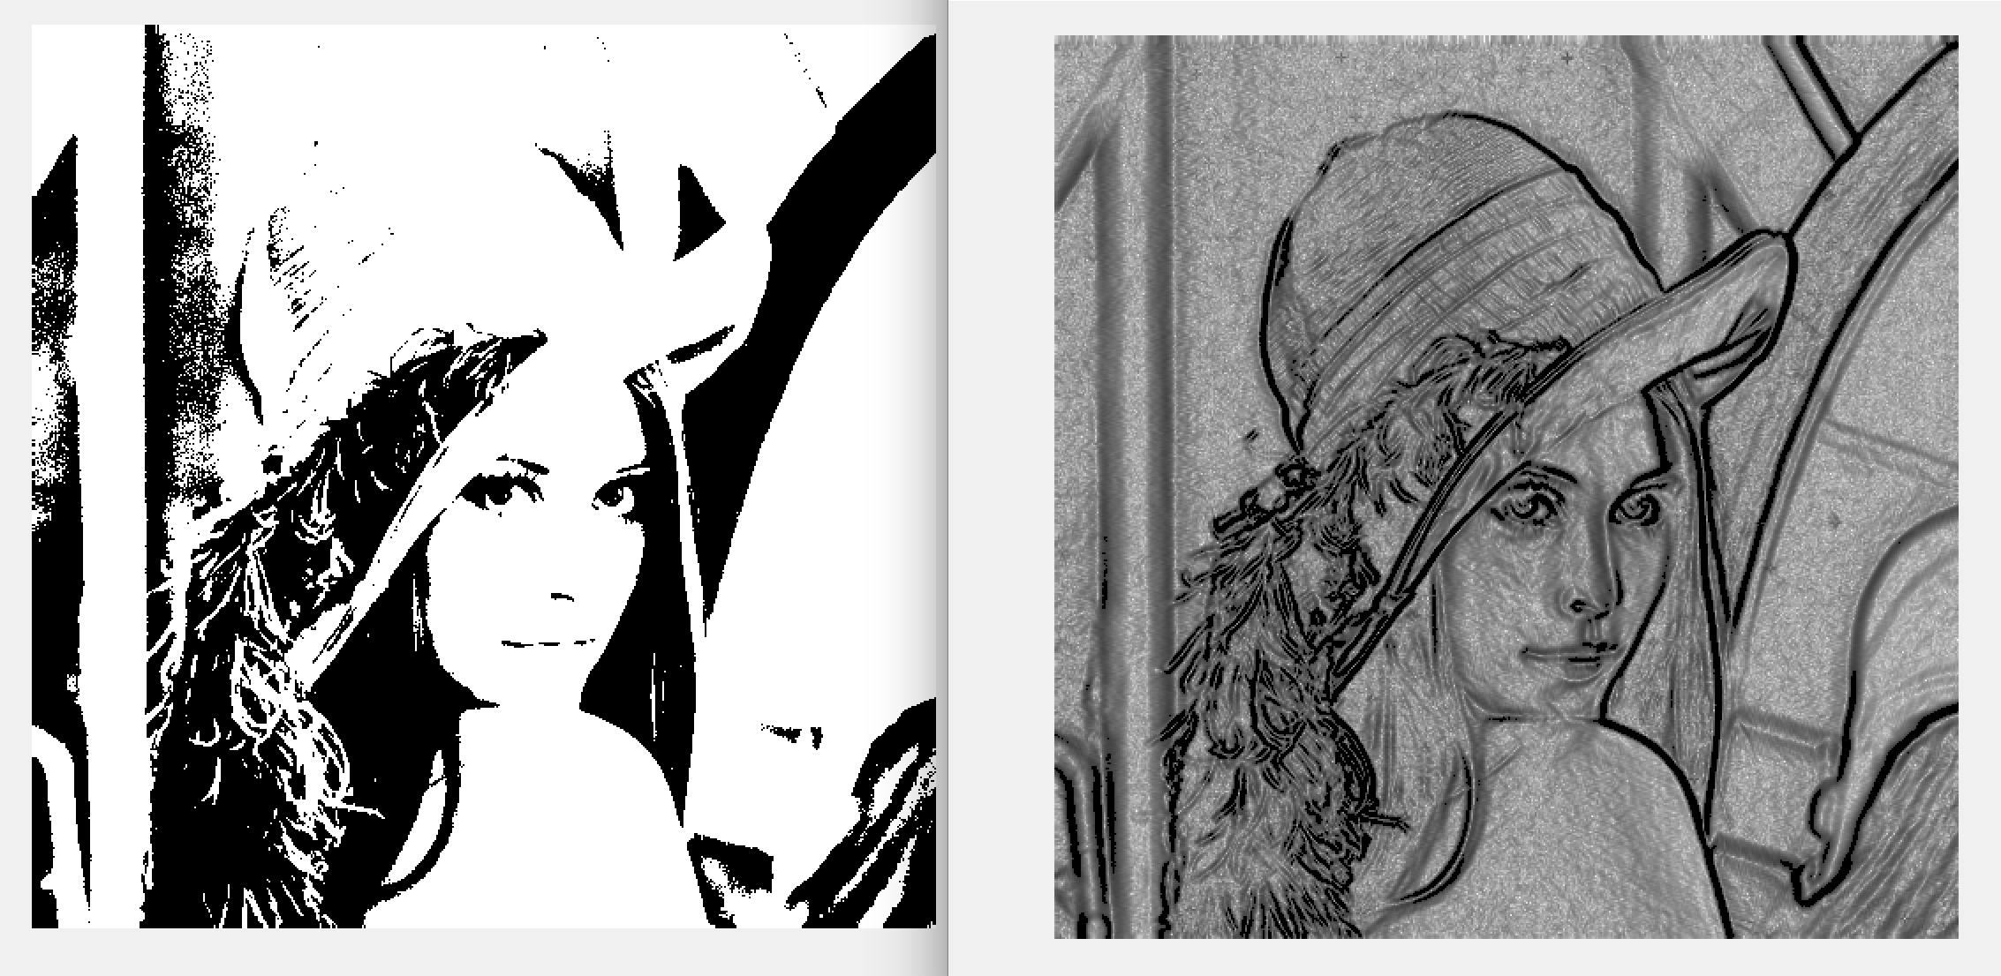

Above image is the logical matrix and the gradient weighted image

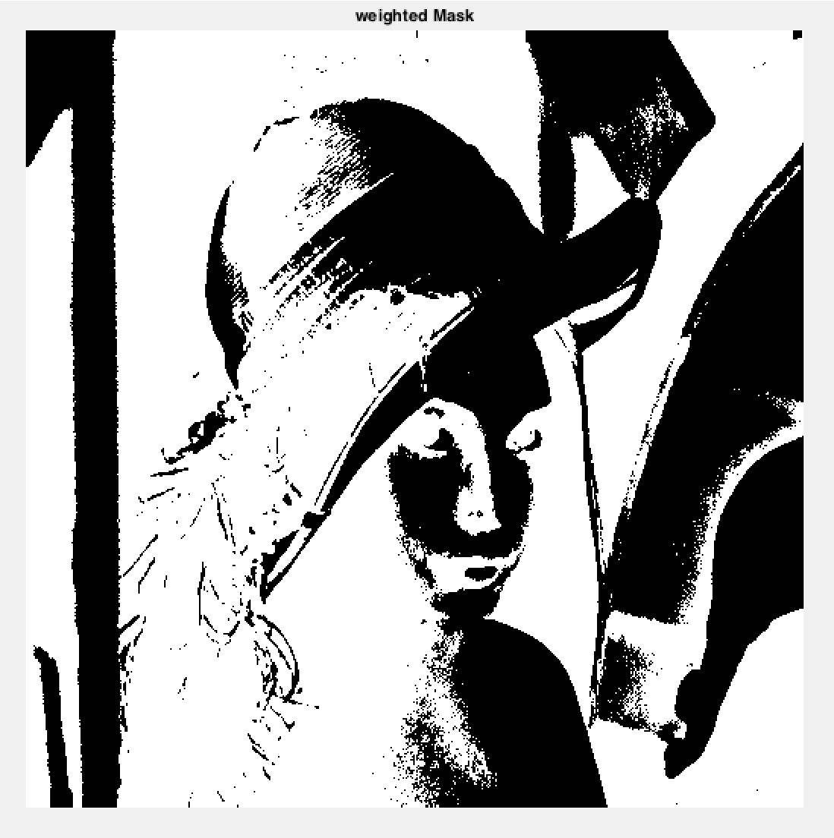

Above image is what I got as my weighted region mask

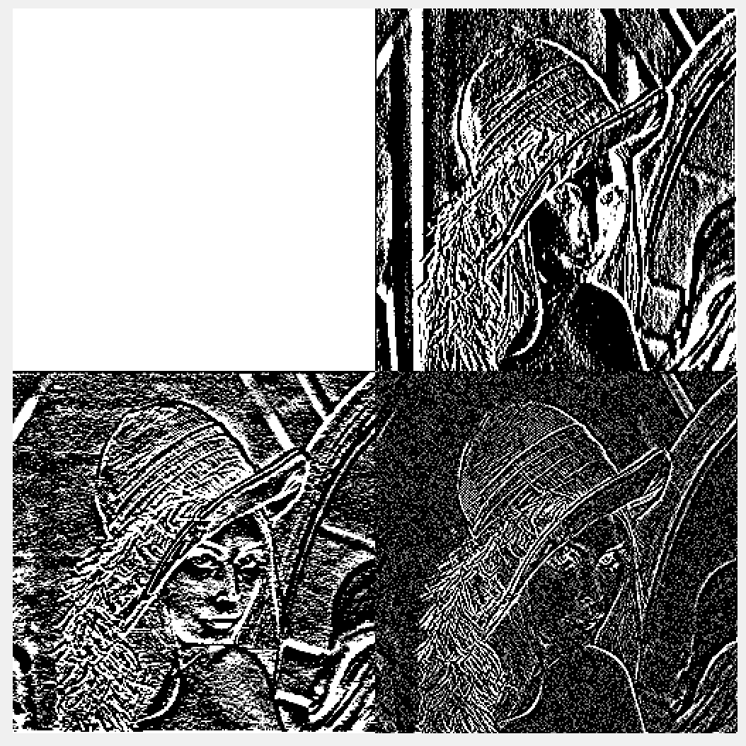

Above image is the result of the Haar Wavelet Decomposition

Aligned Images of the Money

